Title Nazanin Zinouri

**H1 Hi. I’m Nazanin.**

**H1 Table of Contents**

Chapter 1: About Me

Chapter 2: Education

Clemson University

Northern Illinois University

Chapter 3: Professional Experience

Modjoul Inc.

Greenville Health System

Caterpillar Inc.

**H1 About Me**

I am an aspiring data scientist who loves telling stories with data. I studied at Clemson University where I got my Ph.D. in Industrial Engineering-Operations Research. My Masters and Bachelor’s degrees are also in Industrial Engineering. I like to turn business ideas into quantifiable objectives and analysis. I also enjoy driving meaningful insights from data. I want to feel more confident about my programming skills and decided to give this course on Udacity a try! You can find more about me on my LinkedIn (https://www.linkedin.com/in/nazanin-zinouri-4318788b).

**H1 Education**

**H2 Clemson University**

Ph.D. in Industrial Engineering

Clemson University, Clemson, SC

Aug 2013-Aug 2016

GPA 4.0

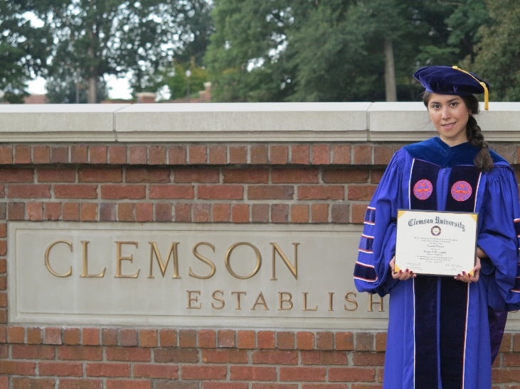

**H2 Northern Illinois University**

M.S. in Industrial Engineering

Northern Illinois University, Dekalb, IL

Aug 2010-Aug 2012

GPA 4.0

**H1 Professional Experience**

**H2 Modjoul Inc.**

Working at Modjoul helped me get my foot into the professional data science and analytics door. Here at Modjoul, we build machine learning algorithms for human activity recognition.

**H2 Clemson university / Greenville Health Systems**

During my Ph.D. years at Clemson university, I worked with a team on working Periop MLS app for Greenville Health Systems. Periop MLS is a smart mobile application designed to be used by surgeons, nurses, CRNAs, and anesthesiologists on the day of surgery. A focal point of this project is to embrace and enhance mobile technology to facilitate patient flow through Periop (Pre-op, OR, and PACU) by improving coordination between units and advancing post-hoc analysis. You can learn more about this cool app from this video (<https://youtu.be/nkG10d9xZv4>).

**H2 Northern Illinois University / Caterpillar Inc.**

While I was working on my Master’s degree at Northern Illinois University, I got the chance to do an “*engineer in residence*” program at Caterpillar Inc. where I developed a discrete event simulation model to study storage utilization.